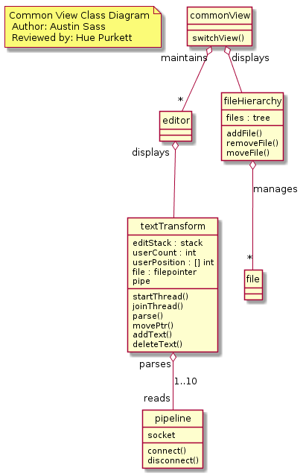  
  
@startuml

hide circle

note "Common View Class Diagram\n Author: Austin Sass \n Reviewed by: Hue Purkett" as Nhue2

class commonView {

switchView()

}

class editor {  
}

class textTransform {

editStack : stack

userCount : int

userPosition : [] int

file : filepointer

pipe

startThread()

joinThread()

parse()

movePtr()

addText()

deleteText()

}

class pipeline {

socket

connect()

disconnect()

}

class fileHierarchy {

files : tree

addFile()

removeFile()

moveFile()

}

class file {

}

commonView "maintains" o-- "\*" editor

commonView "displays" o-d- fileHierarchy

fileHierarchy o-d- "\*" file : manages

editor "displays" o-- textTransform

textTransform "parses" o-- "reads" pipeline : 1..10

@enduml